
RCS Newsletter-portlet

User's Guide

Document Revisions
Date | Revision | By
December 9th, 2014 | 1 | Alejandro Alvarez

Table of Contents

RCS Newsletter-portlet 1
User's Guide 1
Document Revisions 2
General Description 4
Architecture 4
Installation 5
Setting up the portal to use RCS Newsletter-portlet 6
Database 6
Configuring Pages 7
Instantiating RCS Newsletter-portlet Portlet 8
Newsletter-portlet configuration 10
Lists tab 10
Adding a list. 10
Configuring the list’s subscribe, unsubscribe and greeting emails bodies. 11
Updating or Deleting a list. 12
Subscribers tab 12
Exporting active subscribers 12
Importing subscribers 13
Templates tab 14
In this tab is where you manage the templates used to create a mailing. 14
Adding a template: 14
4.Before to paste the code, click [<> Source Button] to avoid weird characters, in the editor's tool bar. 14
Mailing tab 17
Adding Web Content to the Newsletter 17
Creating a mailing. 19
Sending the newsletter 20
Archive tab 21
Untagging tab 22
Configure Newsletter Registration Portlet 23
Upgrading from 2.0 version 25

General Description
The aim of this project is to fulfill with all the features of a Newsletter, including mailing lists management, registration and un-registration system, confirmations, newsletter articles history and on-line newsletter visualization. powered by a group of fully configurable and scalable porlets that can be used in any Liferay portal.

Some of the main features are:
- Mailing list management
- Import/Export Subscribers
- Newsletter history
- On line newsletter viewer

Architecture

- Newsletter Administration: is a Control Panel portlet. You can’t decide where to instantiate it. It will be instantiated automatically into the <Your site> / Admin / Site Administration / Content / Newsletter Administration

- Newsletter Registration: using this portlet, you will register for a newsletter, you may add it in wherever page you want.

- Newsletter Confirmation: this portlet may be added to the “home” page of the portal. Its used to confirm that a user has been registered for the newsletter successfully. If you like to change the page, portal-ext.properties file MUST have this key specified:
ONLINE_NEWSLETTER_CONFIRMATION_PAGE=/your-home-page-name

- On-line Newsletter Viewer: this portlet is used to read the subscribed newsletters in the portal page directly. Default page is “online-newsletter”. If you like to change the page name, portal-ext.properties file MUST have this key specified:
ONLINE_NEWSLETTER_VIEWER_PAGE=/your-online-newsletter-page-name/

Installation

Deploy the RCS Newsletter-portlet into your portal. There are several ways to accomplish this. Here is one.

- Log in as an admin user and go to Control Panel / App Manager.

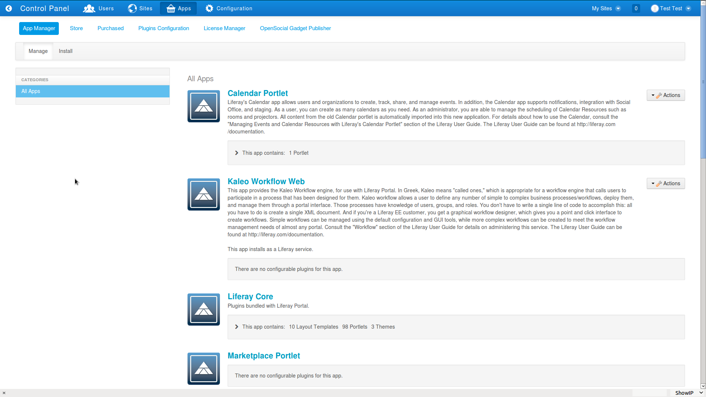Fig 1: All Apps list.

- Click on Install menu button.

- Select File Upload. Click on Choose File / Browse... button, in order to get the file rcs-newsletter-portlet.6.2.1.1.war uploaded from your computer.

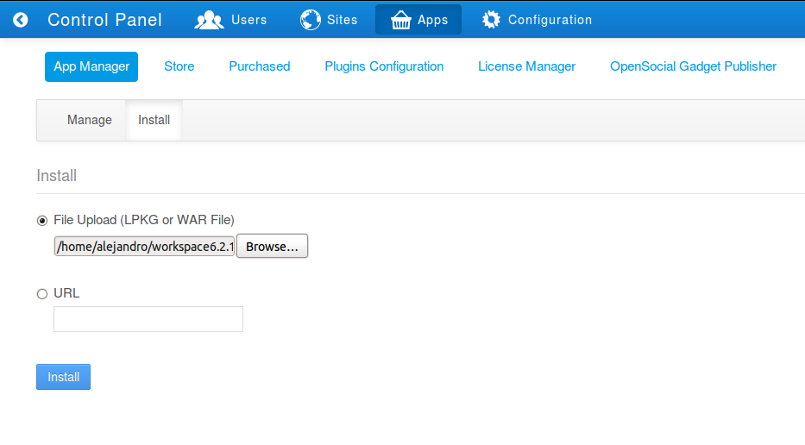Fig 2: Upload a new WAR file.

- Once the file is selected click on the Install button
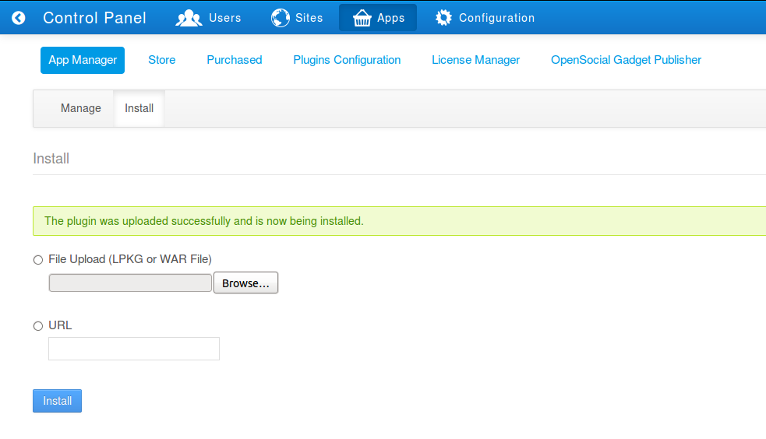Fig 3: WAR uploaded.

Once the newsletter is installed you can start configuring it.

Setting up the portal to use RCS Newsletter-portlet

In order to use RCS Newsletter-portlet, the following configuration is suggested to be set in portal-ext.properties file

journal.article.types=rcs-news,rcs-press-release,rcs-events,rcs-newsletter,rcs-general

Database

The RCS Newsletter-portlet works with any database specified to be used by Liferay except HSQL. It requires do have a driver specified in portal-ext.properties file or to have Liferay set up during the installation to use another Database different than the bundled DEMO HSQL Database.

Configuring Pages
- Log in as an admin user and go to Admin / Site Administration / Pages.
- Click “+ Add Page” under Public Pages tree.
- In the name field you must enter “online-newsletter”. This is because the On-line Newsletter-portlet Viewer needs to be instantiated in a page named like this.
- Select Hide from Navigation Menu check-box.
- Leave other values as default.
- Click on Add Page button.

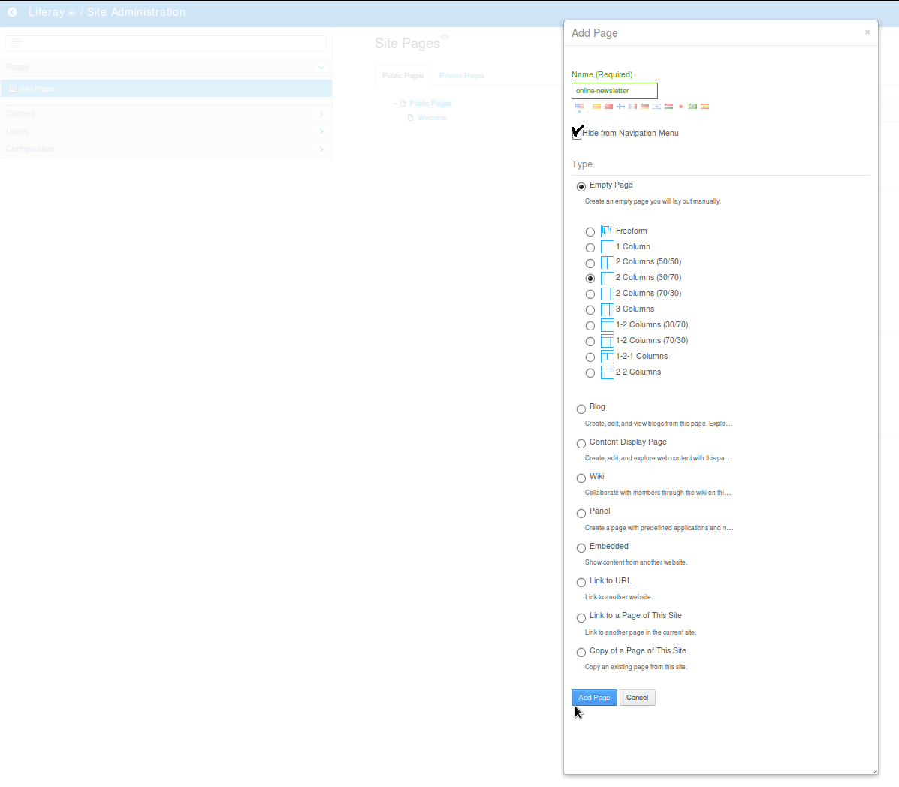Fig 4: Add online-newsletter.

Instantiating RCS Newsletter-portlet Portlet

The application’s portlets should be instantiated as described in the diagram below.

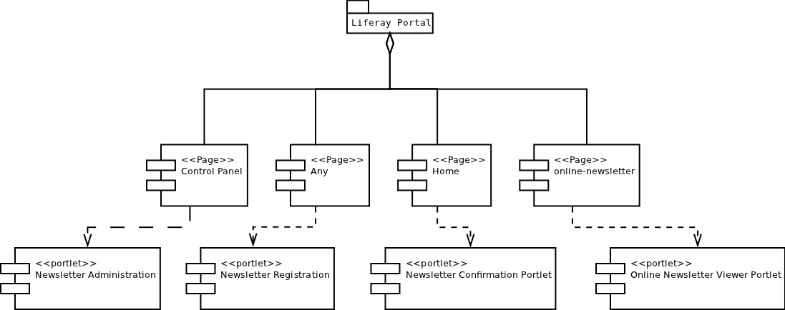Fig 5: RCS Newsletter portlets, as they should be instantiated.

- Log in as an admin user.

- On the top left menu site bar select [+].

- Click Add / Application

- Expand the Rotterdam CS category.

- To instantiate a portlet, just drag and drop it from the list into the page you want it to be displayed.

- On the portal’s “home” page you must instantiate “Newsletter Confirmation Portlet”. This portlet default state is hidden so you won’t see any changes in the home page.

- Instantiate Newsletter Registration Portlet in any page of the portal, or create one for it.

- Instantiate Online Newsletter Viewer Portlet in the page created earlier for it (online-newsletter).
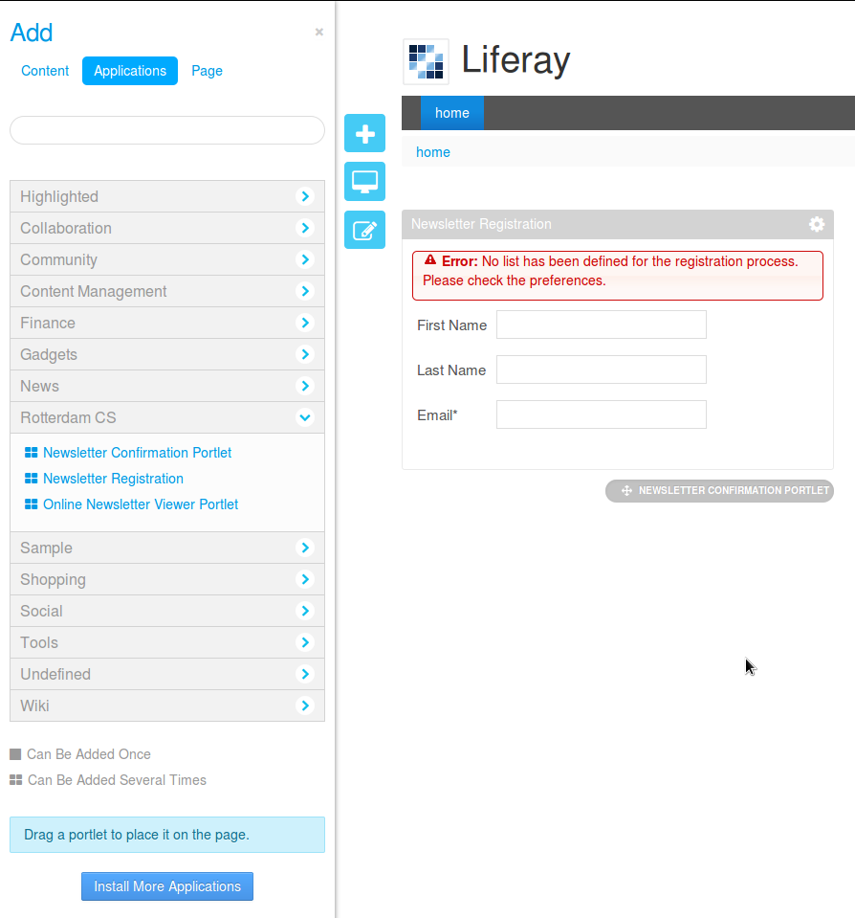Fig 6: Rotterdam CS Newsletter Portlets list.

Newsletter-portlet configuration
The Newsletter Administration section has four tabs: Lists, Subscribers, Mailing and Archive. Each one of this tabs, is used to configure different aspects of the RCS Newsletter-portlet.

To access the Newsletter Administration page follow the steps described below.
- Log in as an admin user and go to Liferay / Site Administration / Content .
- Select Newsletter Administration in the left panel.
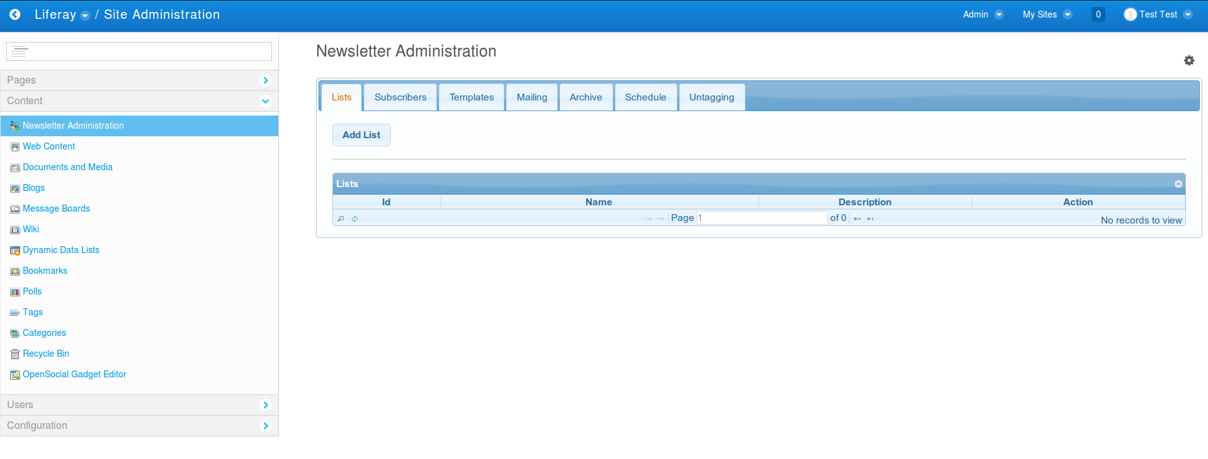Fig 7: Newsletter Administration.

Lists tab
The Lists tab is used to create, update and remove the mailing lists for which newsletters will be sent.

Adding a list.
- Click on Add List.
- Enter a name for the list, its description the name that will be sending the newsletter and the email address used for sending the newsletter. When done, click Save button. You can create many list as you want.
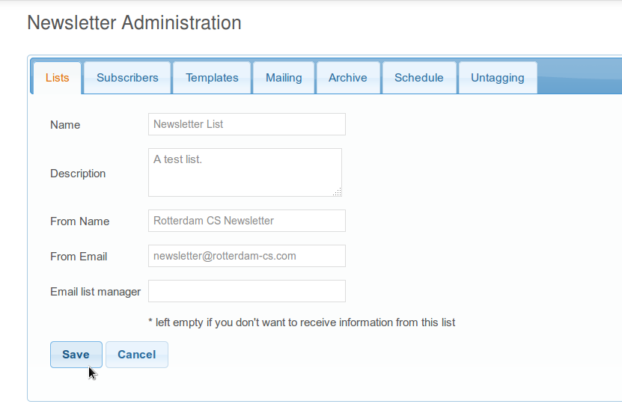Fig 8: List creation.

Configuring the list’s subscribe, unsubscribe and greeting emails bodies.

- In the list you wish to configure, click on Actions button and select the menu item for the email type you want to configure.

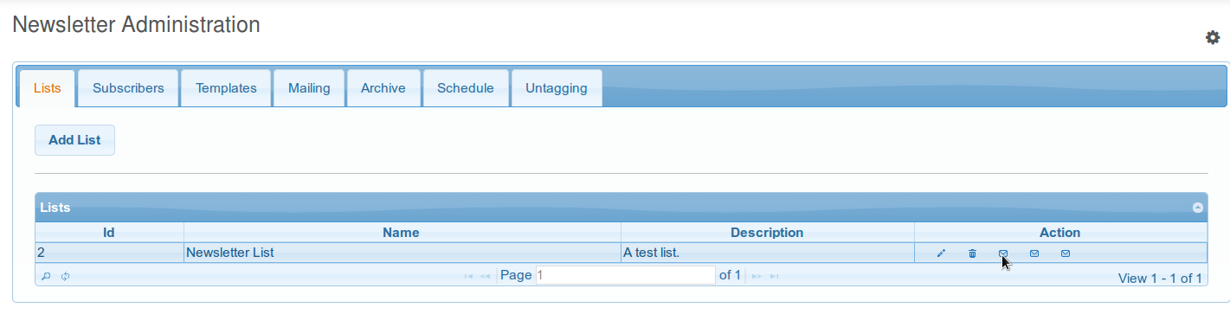Fig 9: List Actions.
- Configure the list to have the three required emails: Greeting, Subscribe, Unsubscribe. If you click on Help button, a list of tokens (and their description) that should be inserted in the email to be sent to the registered recipients, is shown.
- If you copy the text, before to paste the code, click [<> Source Button] to avoid weird characters, in the editor's tool bar.

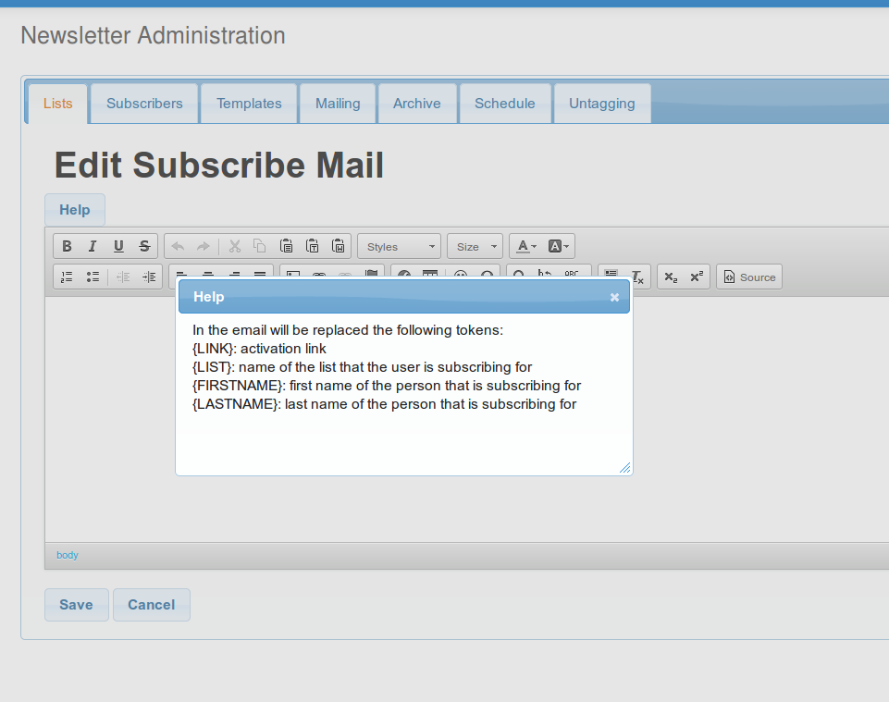Fig 10: Email edition help window.

- Edit the email body using the tools in the editor window.
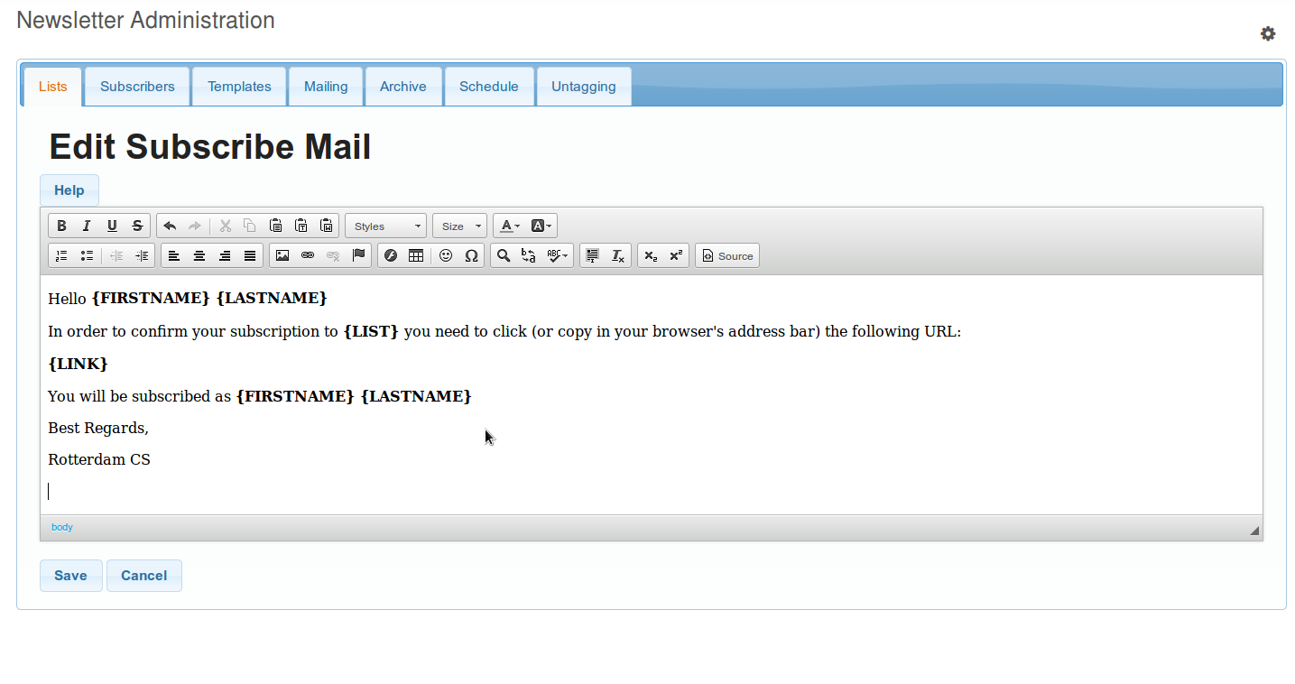Fig 11: Subscribe email message creation.

Note: Remember to include the token {LINK}, so the user can confirm his registration.

- Repeat previous steps in order to create the email messages for Greeting and Unsubscribe actions. Remember that the Help button displays the tokens that should be included in the email message body.

Updating or Deleting a list.
- In the list you wish to update or delete, click on Action's desired icon that you are trying to perform.

Subscribers tab
In this tab you’ll see the subscribers of each list displayed in a grid. Also, you can choose either to display or not, the inactive subscribers of each list.
Also in this tab you can import or export subscribers into/from a list.

Exporting active subscribers

In the Subscribers tab click on Export active subscribers to excel button. An Excel file is downloaded, with the following columns:

id: the internal ID of the subscriber.
Name: subscriber’s name.
Last Name: subscriber’s last name.
Email: subscriber’s registered email address.

Importing subscribers

The Excel file (only *.xls) to be imported, must have the following columns:

Name: subscriber’s name.
Last Name: subscriber’s last name.
Email: subscriber’s registered email address.

- In the Subscribers tab, click on Import Subscribers button.
- Choose a List, onto which the subscribers will be imported, or all list.
- Click choose file, and browse for the Excel file containing the subscribers data.
- Click Import button.

Note: Instead of creating a new Excel file, you can use a downloaded earlier with up to date data. (The value of the id column isn’t necessary and its recommended to leave it blank)

Templates tab

In this tab is where you manage the templates used to create a mailing.

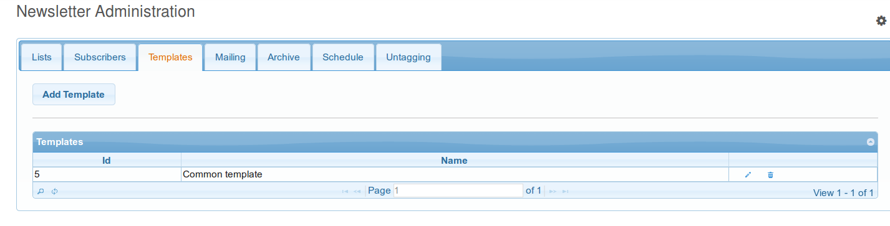Fig 12: Templates tab.

Adding a template:

- Log in as an admin user and go to Liferay / Site Administration / Content.

- Select Newsletter Administration in the left panel and go to Templates tab. Click on Add Template button. Fill Name field with the name of the template you are creating something like “Common template”. Click on Help button, a list of tokens (and their description) that can be inserted in the email to be sent to the registered recipients, is shown.

- Copy one of the [block] [/block] sections .

- Before to paste the code, click [<> Source Button] to avoid weird characters, in the editor's tool bar.

- Paste it on the editor. Each block will be replaced with an article when you create a mailing, you have to create at least one block.

- Click Save button.

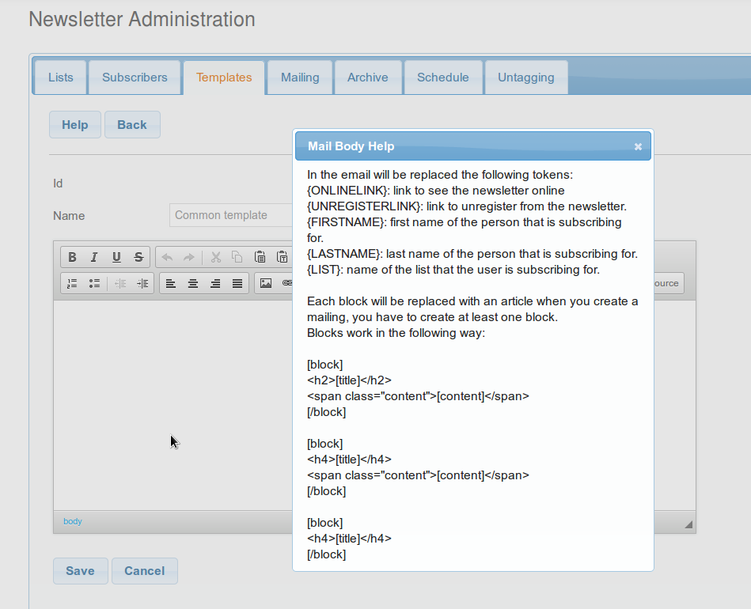Fig 13: Templates Help window

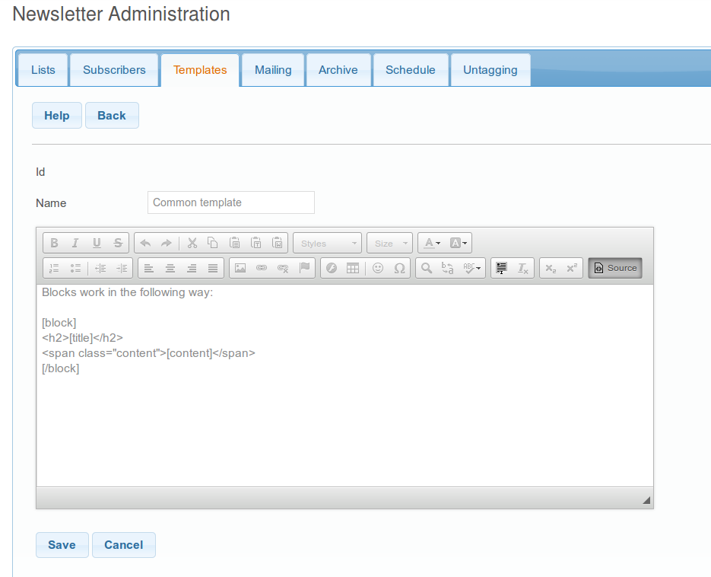Fig 14: Paste in Source Editing Mode

Mailing tab

In this tab is where you select the content and send a newsletter.

Adding Web Content to the Newsletter

Once you have configured your portal the steps to add a web content to be used in a mailing are as follow:

- Log in as an admin user and go to Liferay / Site Administration / Content.

- Select Web Content in the left panel.

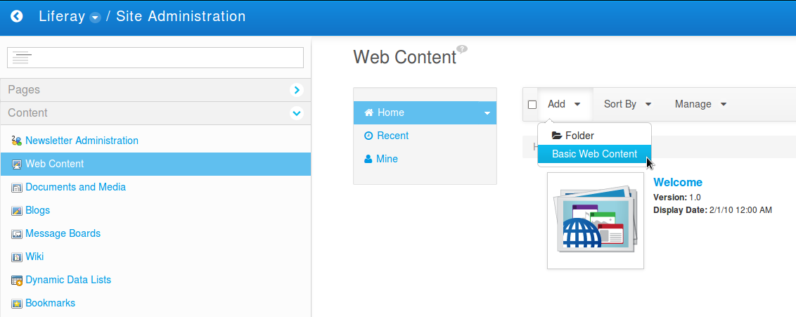Fig 15: Web Content Section.

- Click on Add / Basic Web Content button.

- Fill Name field with the name you want to give to the web content that will be used in the newsletter mailing.

- Edit the web content using the editor.
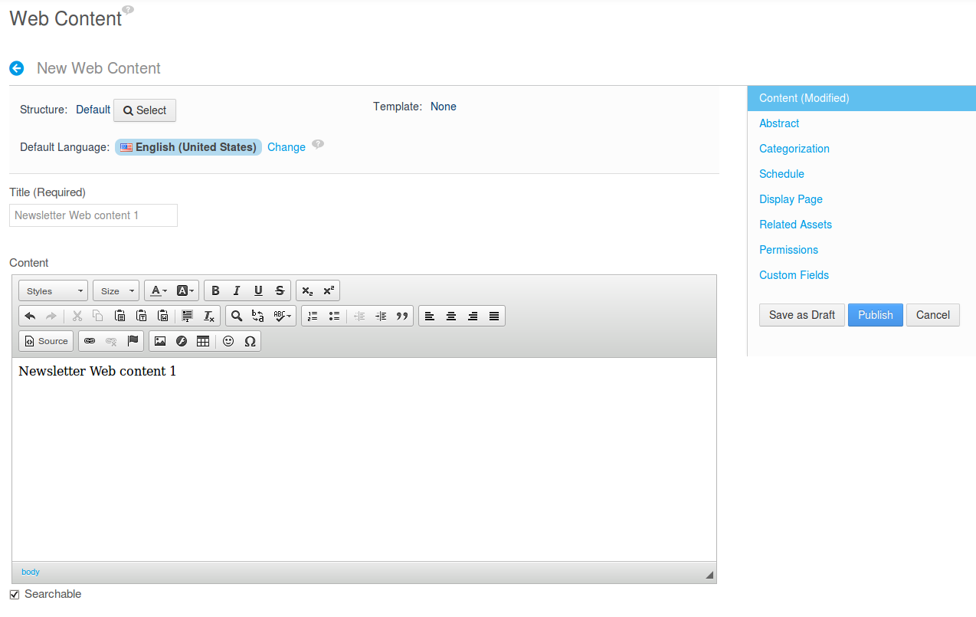Fig 16: Adding Web Content.

- In Categorization section choose at least one of the following methods.

Type: choose rcs-newsletter, if it wass added to portal-ext.properties.

Categories: You'll need to create a category in Liferay / Site Administration / Content / Categories, name it newsletter.

Tags: Just type newsletter.
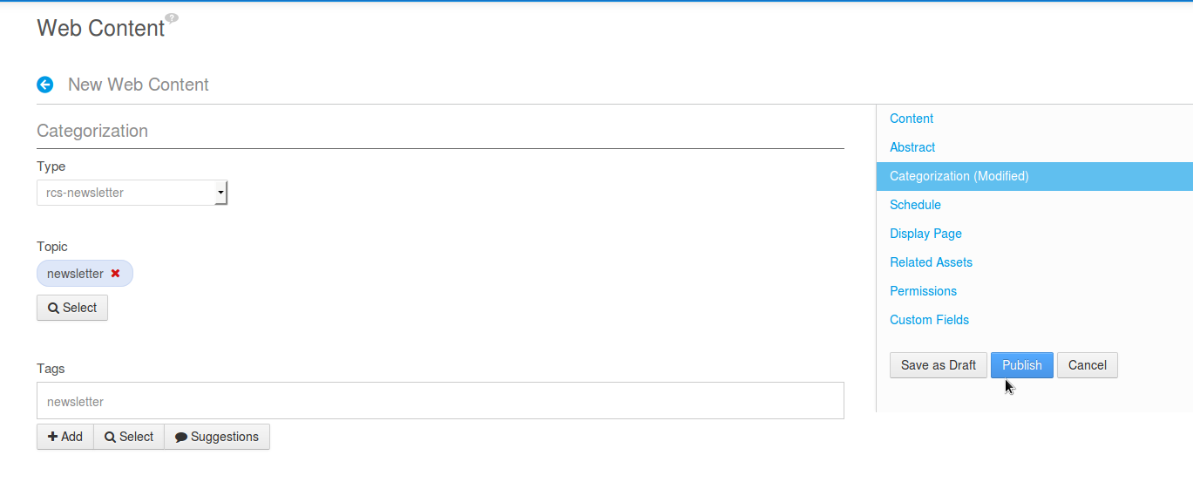Fig 17: Web Content Editor - Categorization Section.

- Click on Publish button.

Creating a mailing.

- Log in as an admin user and go to Liferay / Site Administration / Content.

- Select Newsletter Administration in the left panel and go to Mailing tab.

- Click on Add Mailing button.

- Type the name of the mailing to be sent in the Name field.

- Choose the list where the mailing will be sent from the List dropdown.

- From the Template dropdown, choose a previously created template.

- Select an article for each block added to the selected template.

- Click on Add Mailing button.
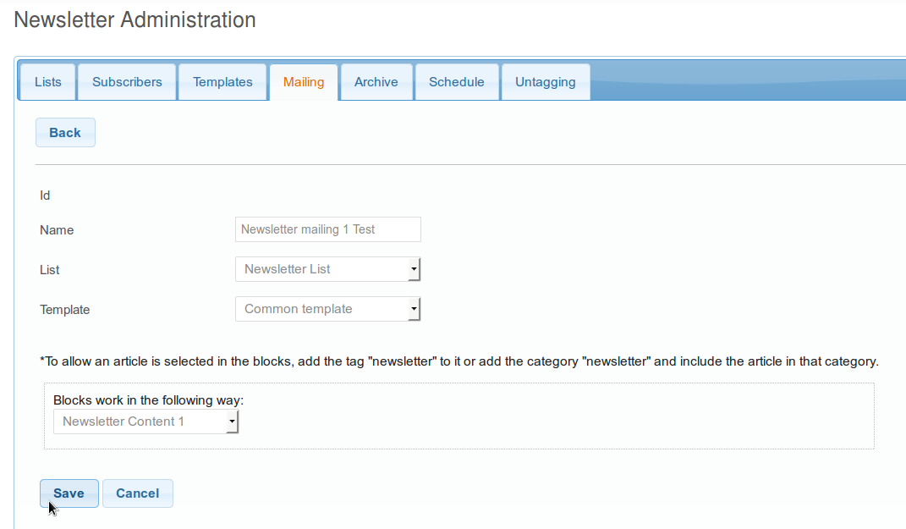Fig 18: Add Mailing.

Sending the newsletter

- Select the radio button for the mailing you want to send and click on Send Newsletter button. Optionally you can fill a test email address and click on Send Test button, in order to see how the email is displayed.

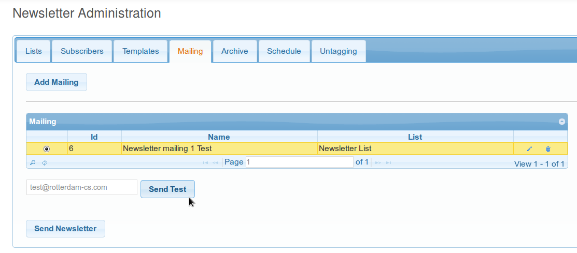Fig 19: Send Newsletter.

- In the Send Newsletter confirmation window, review the data shown and if you agree with it, click on Send Newsletter button. Otherwise click Cancel, or Schedule Newsletter.
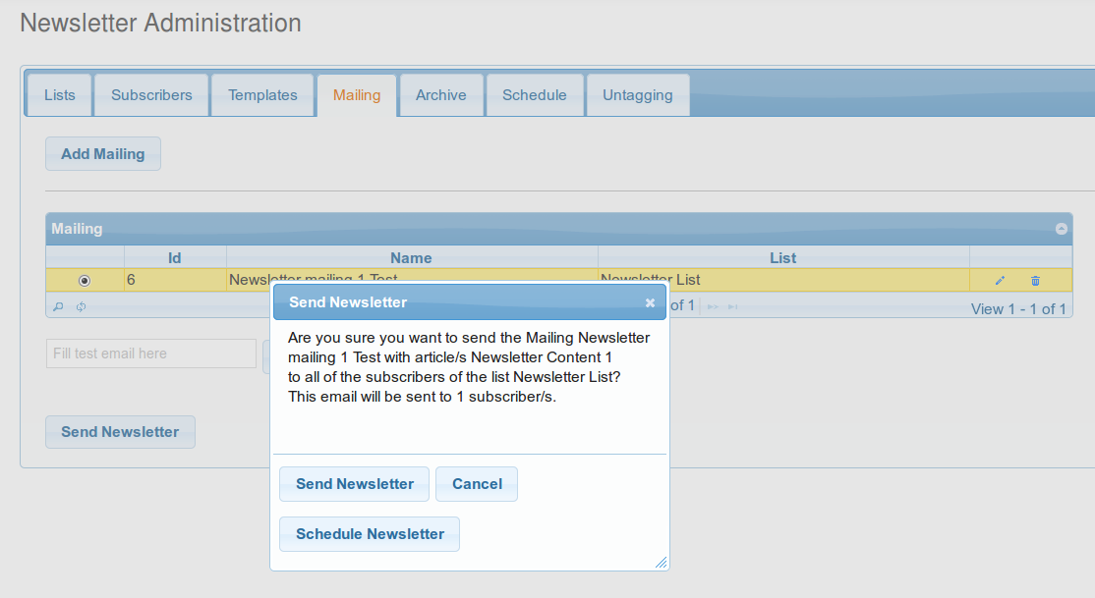Fig 20: Newsletter confirmation.

- If the newsletter is wanted to be Scheduled, select corresponding date and time for the newsletter to be sent. Then Close the popup.

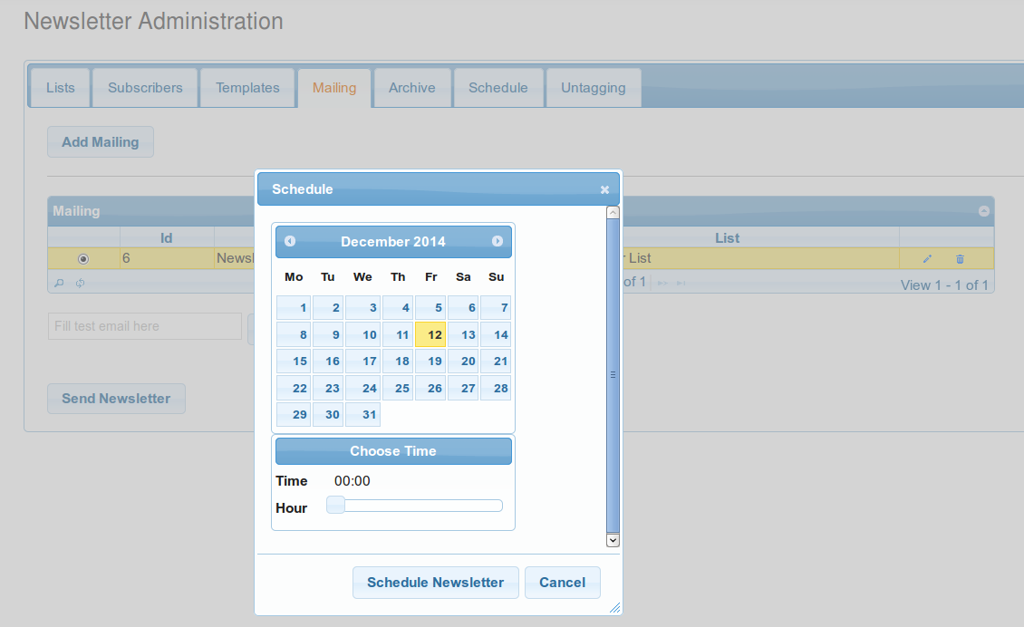Fig 21: Newsletter Schedule Window.

Archive tab
In this tab is where the newsletters sent previously are stored.
It contains a grid with the following structure:

Id: Is the internal ID of the newsletter.

Name: Contains the name of the archived newsletter.

List: The list to which the newsletter was sent.

Date: The date where the newsletter was sent.

View Details Icon: An option to see sent newsletter.

Untagging tab

In this tab you can remove the tag, type and category of the web contents that are used in the mailing tab.

A warning is displayed saying:

“If you remove the tags of this web content, you can still send the mailing, but you can't edit it anymore. Are you sure you want to untag this webcontent?”

Configure Newsletter Registration Portlet
Let’s suppose that you want to have two different news letters in your site, one about wines and another about food.

RCS Newsletter allow your users to register in any amount of newsletters you define in your site.

In order to accomplish this you need to have as many Newsletter Registration Portlet instances (each one associated to a list) as newsletters you wish to have.

- Log in as an admin user and go to the page that host the instance you want to configure.

- Click on the wrench tool icon, a menu will expand, select Preferences.

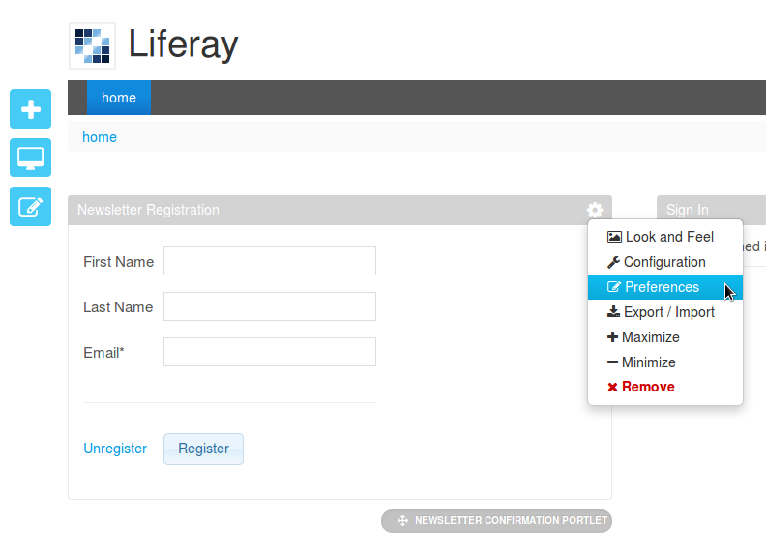Fig 22: Preferences menu of Newsletter Registration Portlet.

- In the Newsletter Registration Settings, select the list to associate to the portlet from the List dropdown. Optionally, you can choose not to require the Name and Last Name of the user by ticking Disabled Name fields checkbox. When done click Save Settings button.

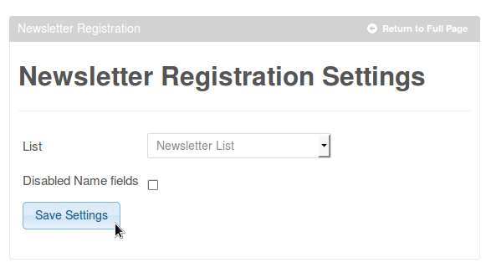

- In order to return to the normal view just click Return to full page.

Upgrading from 2.0 version

In order to accomplish this, the first you need to do is to uninstall the rcs newsletter portlet 2.0 and install the rcs newsletter portlet 2.1.
Then you need to run the following script in your liferay database

“Alter table newsletter_mailing drop column articleid;”

After you running this script you are able to use the new version of the portlet.

The portal-ext.properties file should be located at <LIFERAY_HOME>/Liferay-portal-X.X.X/portal-ext.properties

